PACKET ARCHITECTURE

- SPACE PACKET
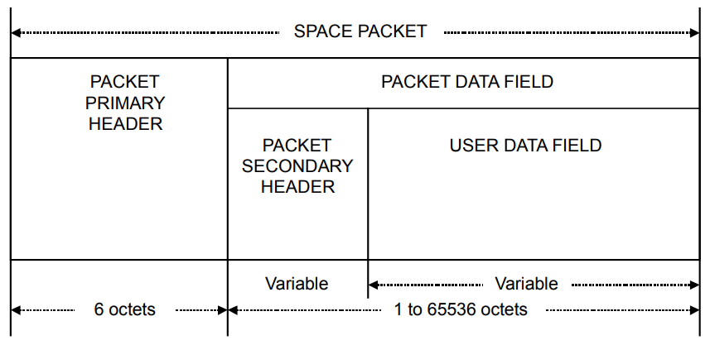
Space Packet Structural Components
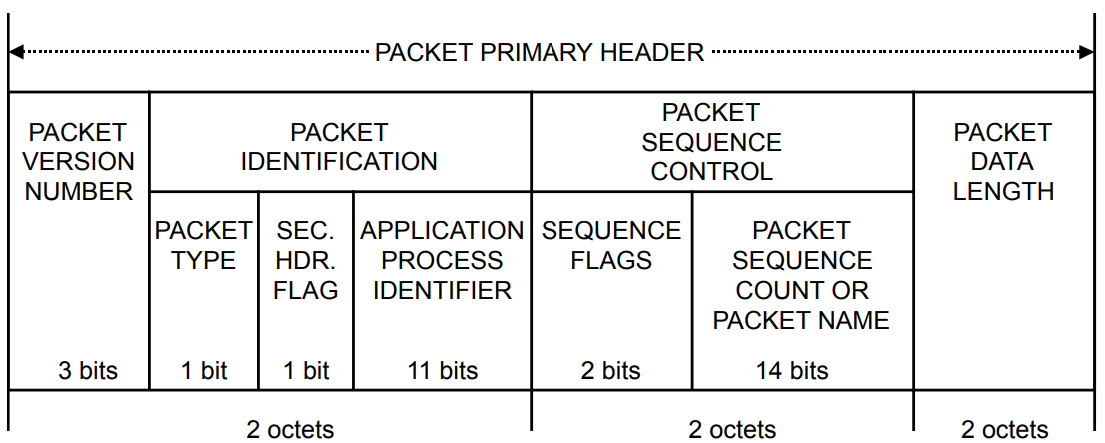
Packet Primary Header
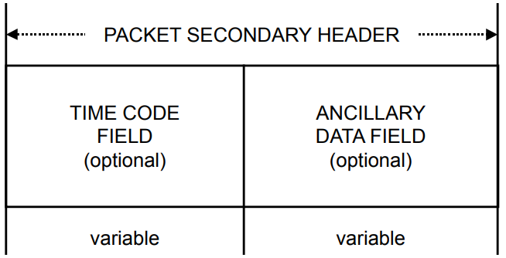
Packet Secondary Header
- TRANSFER FRAME
- Telecommand
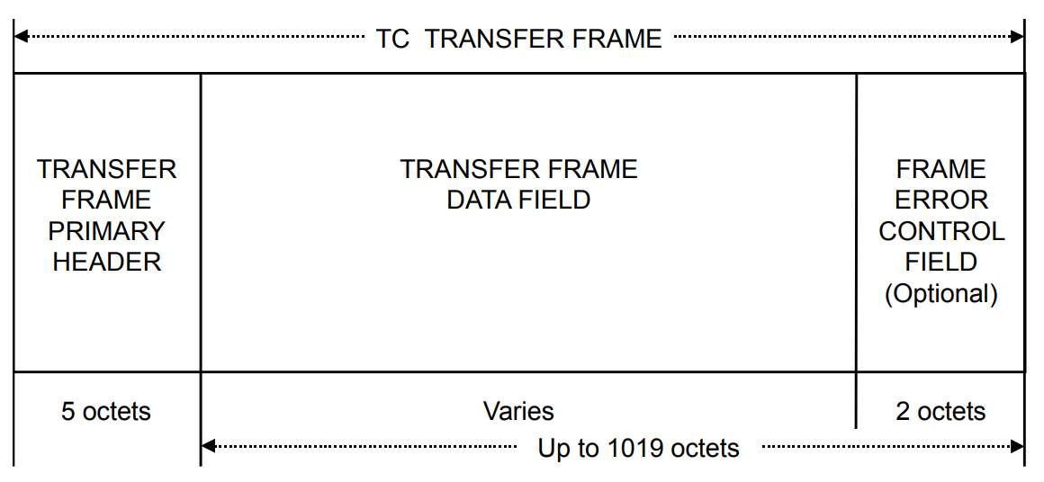
TC Transfer Frame Structural Components
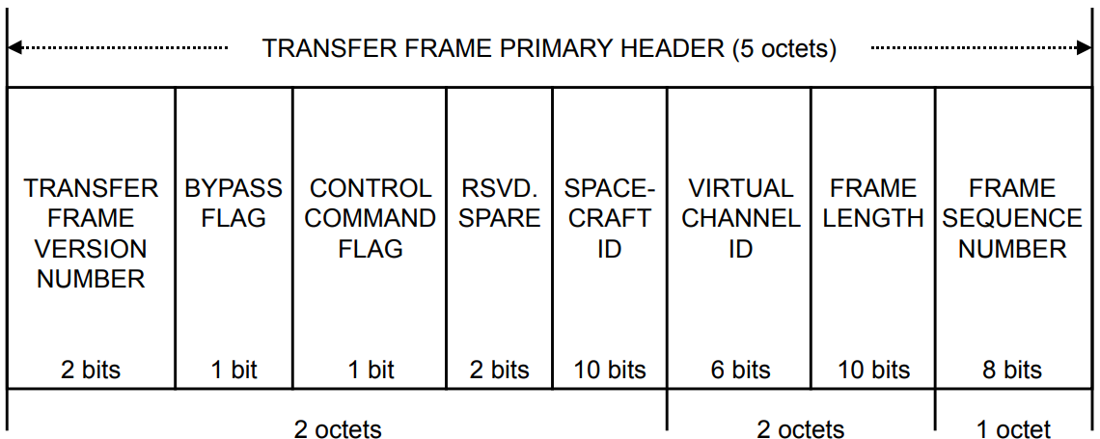
Transfer Frame Primary Header

